|  |  |
| --- | --- |
| ID number | #1 |
| Name | **Text overlapping side menu buttons** |
| Reporter | Sanja Vasiljevic |
| Submit Date | 24/04/2022 |
| URL | http://www.gatesnfences.com/index.html |
| Platform | Windows 10 Pro Version 21H2 |
| Operating System | OS build 19044.1645 |
| Browser | Google Chrom Version 100.0.4896.127 |

**Steps to reproduce**

1. Open the http://www.gatesnfences.com/index.html
2. Check the left side menu of the page
3. It is not displayed correctly, words are overlapping the buttons.

**Screenshot**

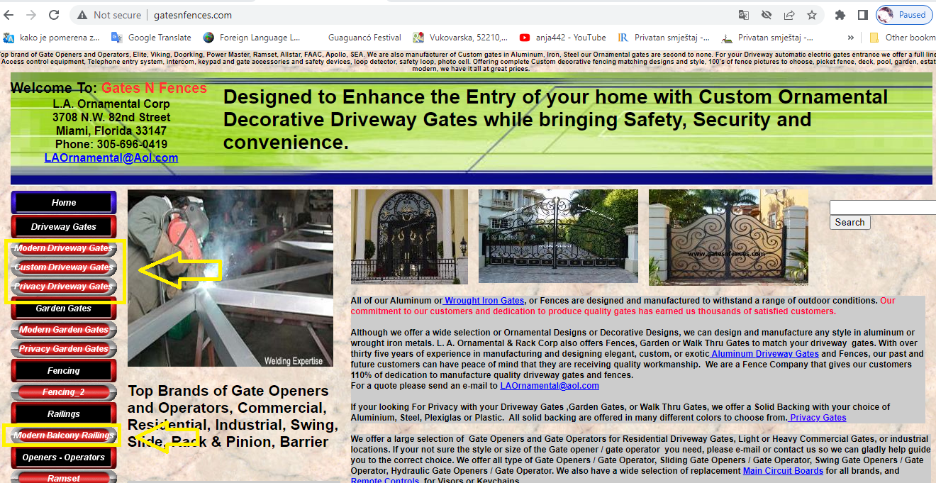

|  |  |
| --- | --- |
| ID number | #2 |
| Name | **Search button does not work** |
| Reporter | Sanja Vasiljevic |
| Submit Date | 24/04/2022 |
| URL | http://www.gatesnfences.com/index.html |
| Platform | Windows 10 Pro Version 21H2 |
| Operating System | OS build 19044.1645 |
| Browser | Google Chrom Version 100.0.4896.127 |

**Steps to reproduce**

1. Open the http://www.gatesnfences.com/index.html
2. Write “Driveway_gates” at search button on the right side
3. It is open empty new page <http://www.gatesnfences.com/.search?results_page=&p=Driveway_gates&name=Search>

with notes “Unauthorized”

**Screencast**

[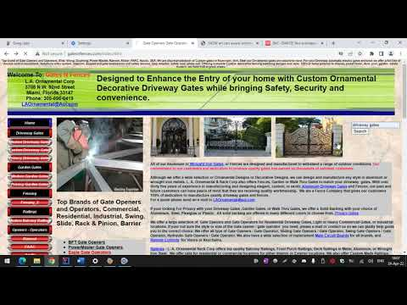](https://www.youtube.com/embed/yI3Bkr2YRCU?feature=oembed)

|  |  |
| --- | --- |
| ID number | #3 |
| Name | **Greeting text is missing in the header of the “Driveway Gates” page** |
| Reporter | Sanja Vasiljevic |
| Submit Date | 24/04/2022 |
| URL | http://www.gatesnfences.com/index.html |
| Platform | Windows 10 Pro Version 21H2 |
| Operating System | OS build 19044.1645 |
| Browser | Google Chrom Version 100.0.4896.127 |

**Steps to reproduce**

1. Open the http://www.gatesnfences.com/index.html page
2. Click on “Driveway Gates” button at the side bar
3. The “Driveway Gates” page will be displayed
4. Check the header of the page
5. It is not displayed correctly, words are overlapping “**Welcome to: GATESNFENCES.COM”**

**Screenshot**

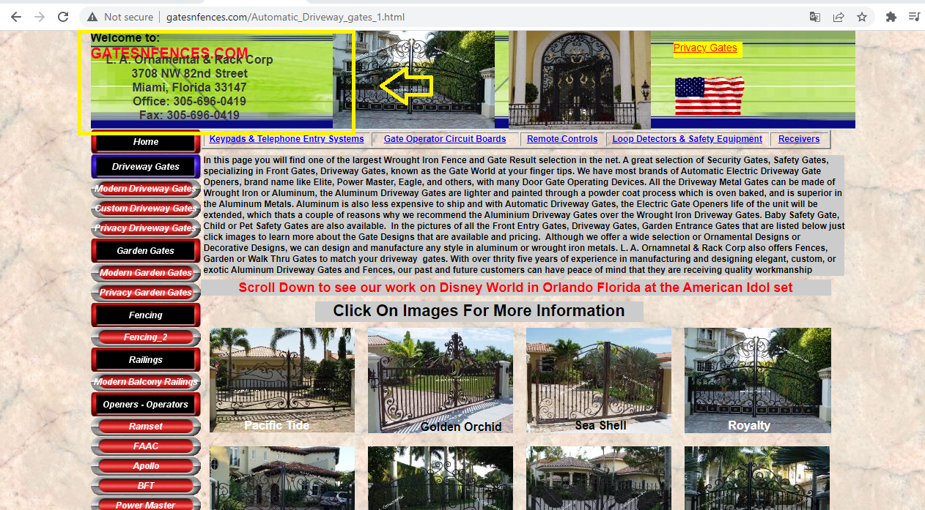

|  |  |
| --- | --- |
| ID number | #4 |
| Name | **Unexpected elements in the footer of the “Pacific Tide Automatic Driveway Gate” page** |
| Reporter | Sanja Vasiljevic |
| Submit Date | 24/04/2022 |
| URL | http://www.gatesnfences.com/index.html |
| Platform | Windows 10 Pro Version 21H2 |
| Operating System | OS build 19044.1645 |
| Browser | Google Chrom Version 100.0.4896.127 |

**Steps to reproduce**

1. Open the http://www.gatesnfences.com/index.html page
2. Click on the Driveway Gates button from the left side menu
3. The Gallery will be displayed
4. Scroll down
5. Check the page
6. Unexpected elements are displayed

**Screencast**

[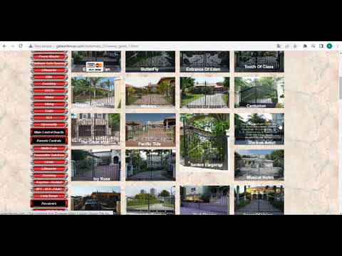](https://www.youtube.com/embed/LjhAcCMMHII?feature=oembed)

|  |  |
| --- | --- |
| ID number | #5 |
| Name | **The header of the “Privacy Gates” page is not displayed properly** |
| Reporter | Sanja Vasiljevic |
| Submit Date | 24/04/2022 |
| URL | <http://www.gatesnfences.com/index.html> |
| Platform | Windows 10 Pro Version 21H2 |
| Operating System | OS build 19044.1645 |
| Browser | Google Chrom Version 100.0.4896.127 |

**Steps to reproduce**

1. Open the http://www.gatesnfences.com/index.html page
2. Click on the “Privacy Gates”button on theleft side bar
3. The “Privacy Gates” page will be displayed
4. Check the header of the page
5. It is not displayed correctly, words are overlapping the menu bar

**Screenshot**

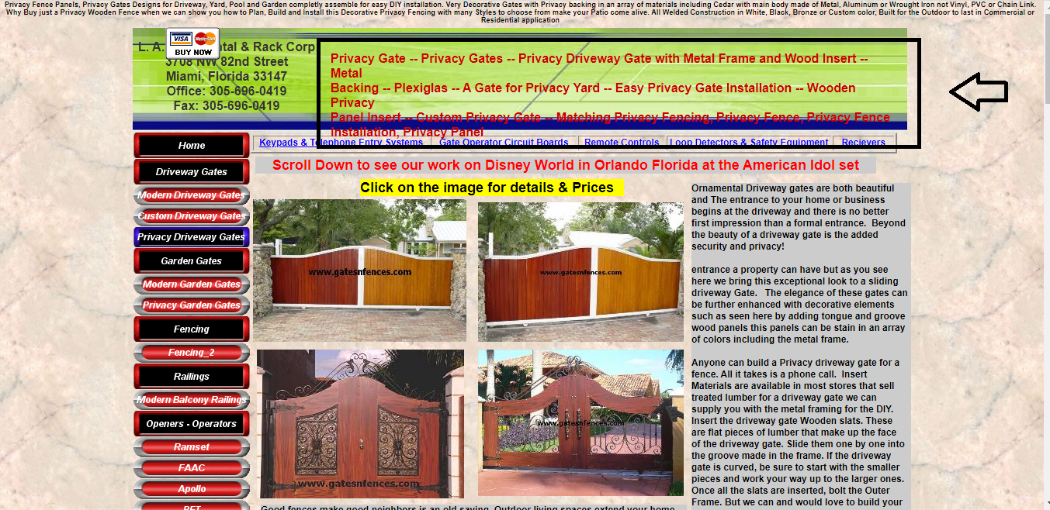

|  |  |
| --- | --- |
| ID number | #6 |
| Name | **Greeting text is missing in the header of the “Privacy Gates” page** |
| Reporter | Sanja Vasiljevic |
| Submit Date | 24/04/2022 |
| URL | <http://www.gatesnfences.com/index.html> |
| Platform | Windows 10 Pro Version 21H2 |
| Operating System | OS build 19044.1645 |
| Browser | Google Chrom Version 100.0.4896.127 |

**Steps to reproduce**

1. Open the http://www.gatesnfences.com/index.html page
2. Click on the “Privacy Gates”button on theleft side bar
3. The “Privacy Gates” page will be displayed
4. Check the header of the page
5. “Welcome To: Gates N Fences” text is missing in upper left corner

**Screenshot**

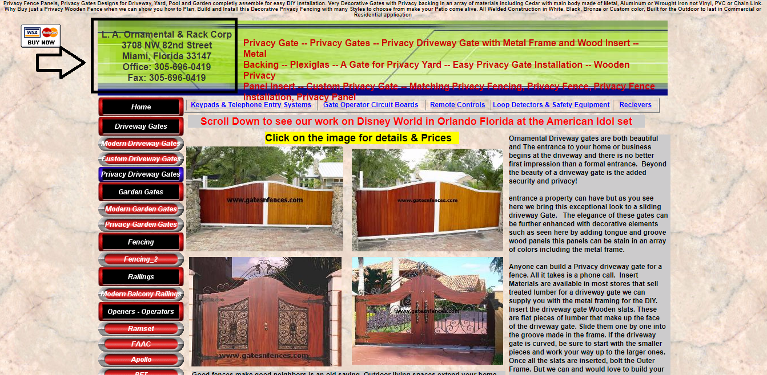

|  |  |
| --- | --- |
| ID number | #7 |
| Name | **Color Chart image on the “Privacy Gates” page is misplaced** |
| Reporter | Sanja Vasiljevic |
| Submit Date | 24/04/2022 |
| URL | <http://www.gatesnfences.com/index.html> |
| Platform | Windows 10 Pro Version 21H2 |
| Operating System | OS build 19044.1645 |
| Browser | Google Chrom Version 100.0.4896.127 |

**Steps to reproduce**

1. Open the http://www.gatesnfences.com/index.html page
2. Click on the “Privacy Gates”button on theleft side bar
3. The “Privacy Gates” page will be displayed
4. Scroll down
5. Check the Color Chart image
6. It should be in the right sidebar (like on [this link](http://www.gatesnfences.com/Aluminum_Driveway_Gates_3.html))

**Screenshot  
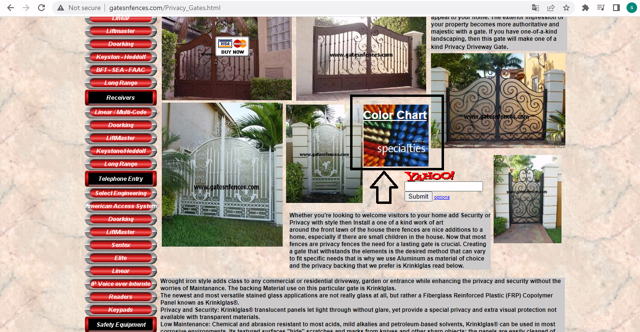**

|  |  |
| --- | --- |
| ID number | #8 |
| Name | **Yahoo! Search bar on the “Privacy Gates” page is misplaced** |
| Reporter | Sanja Vasiljevic |
| Submit Date | 24/04/2022 |
| URL | <http://www.gatesnfences.com/index.html> |
| Platform | Windows 10 Pro Version 21H2 |
| Operating System | OS build 19044.1645 |
| Browser | Google Chrom Version 100.0.4896.127 |

**Steps to reproduce**

1. Open the http://www.gatesnfences.com/index.html page
2. Click on the “Privacy Gates”button on theleft side bar
3. The “Privacy Gates” page will be displayed
4. Scroll down
5. Check the Yahoo! Search bar, it is misplaced
6. It should be in the right sidebar (like on [this link](http://www.gatesnfences.com/Aluminum_Driveway_Gates_3.html))

**Screenshot**

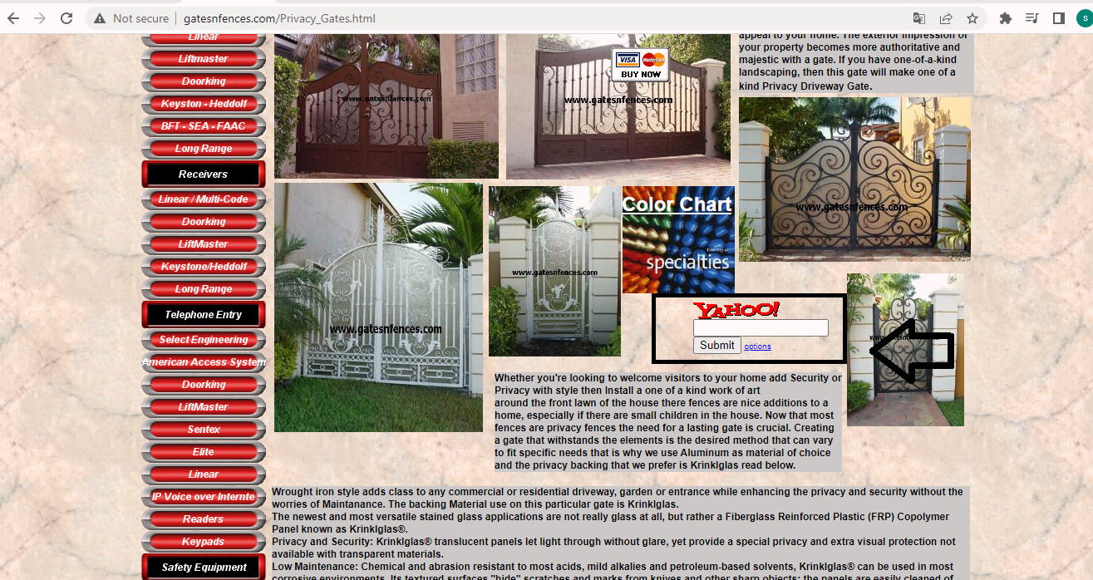

|  |  |
| --- | --- |
| ID number | #9 |
| Name | **“Add To Cart” and “ View Cart” buttons are missing on the “Aluminum Arch Frame Privacy Gate” page** |
| Reporter | Sanja Vasiljevic |
| Submit Date | 24/04/2022 |
| URL | <http://www.gatesnfences.com/index.html> |
| Platform | Windows 10 Pro Version 21H2 |
| Operating System | OS build 19044.1645 |
| Browser | Google Chrom Version 100.0.4896.127 |

**Steps to reproduce**

1.Open the http://www.gatesnfences.com/index.html page

2.Click on the “Privacy Gates”button on theleft side bar

3.The “Privacy Gates” page will be displayed

4.Click on the upper left first image on top of the page

5.The “Aluminum Arch Frame Privacy Gate” page will be displayed

6.Check the price chart on the right

7.The “**Add To Cart**” and “ **View Cart**” buttons are missing (like they are displayed [here](http://www.gatesnfences.com/drivewayhttp:/www.gatesnfences.com/driveway_gates/European_fan-Design-Driveway-Gates-Designs-Custom-Designs.htm))

**Screenshot  
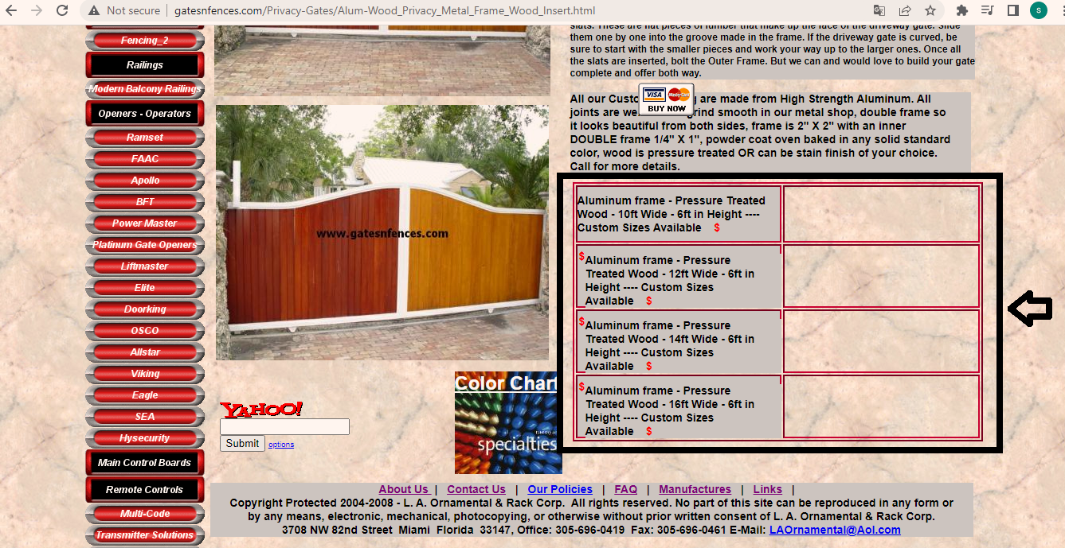**

|  |  |
| --- | --- |
| ID number | #10 |
| Name | **Prices are missing on the “Aluminum Arch Frame Privacy Gate” page** |
| Reporter | Sanja Vasiljevic |
| Submit Date | 24/04/2022 |
| URL | <http://www.gatesnfences.com/index.html> |
| Platform | Windows 10 Pro Version 21H2 |
| Operating System | OS build 19044.1645 |
| Browser | Google Chrom Version 100.0.4896.127 |

**Steps to reproduce**

1. Open the http://www.gatesnfences.com/index.html page
2. Click on the “Privacy Gates”button on theleft side bar
3. The “Privacy Gates” page will be displayed
4. Click on the upper left first image on top of the page
5. The “Aluminum Arch Frame Privacy Gate” page will be displayed
6. Check the price chart on the right
7. The prices are missing

**Screenshot**



|  |  |
| --- | --- |
| ID number | #11 |
| Name | **Yahoo! Search bar on the “Privacy Gates” page is misplaced** |
| Reporter | Sanja Vasiljevic |
| Submit Date | 24/04/2022 |
| URL | <http://www.gatesnfences.com/index.html> |
| Platform | Windows 10 Pro Version 21H2 |
| Operating System | OS build 19044.1645 |
| Browser | Google Chrom Version 100.0.4896.127 |

**Steps to reproduce**

1. Open the http://www.gatesnfences.com/index.html page
2. Click on the “Privacy Gates”button on theleft side bar
3. The “Privacy Gates” page will be displayed
4. Click on the upper left first image on top of the page
5. The “Aluminum Arch Frame Privacy Gate” page will be displayed
6. Check the Yahoo! Search bar, it is misplaced.

**Screenshot**

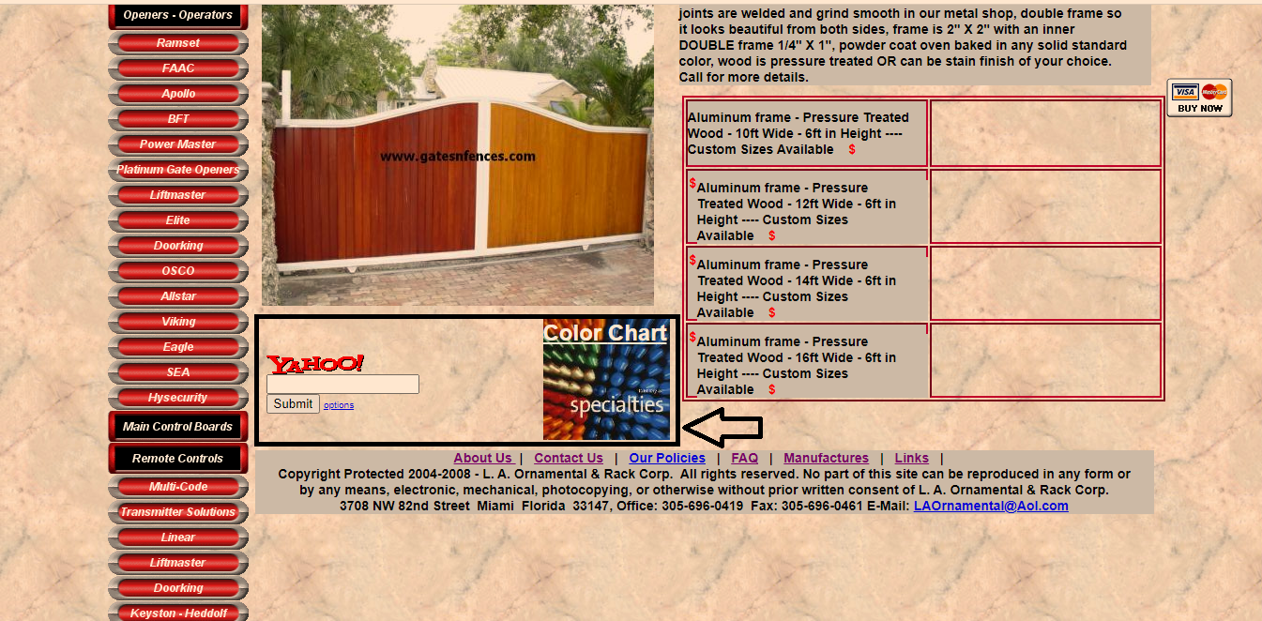

|  |  |
| --- | --- |
| ID number | #12 |
| Name | **The “Mirabella-Privacy-Entrance-Gate” page is not displaying properly** |
| Reporter | Sanja Vasiljevic |
| Submit Date | 24/04/2022 |
| URL | <http://www.gatesnfences.com/index.html> |
| Platform | Windows 10 Pro Version 21H2 |
| Operating System | OS build 19044.1645 |
| Browser | Google Chrom Version 100.0.4896.127 |

**Steps to reproduce**

1. Open the http://www.gatesnfences.com/index.html page
2. Click on the **“**Privacy Gates**”** button on theleft side bar
3. The “Privacy Gates” page will be displayed
4. Click on the lower left image (3 image) on top of the page
5. The “Mirabella-Privacy-Entrance-Gate” page will be displayed
6. Check the page
7. All the content is moved to the right side of the page

**Screenshot**

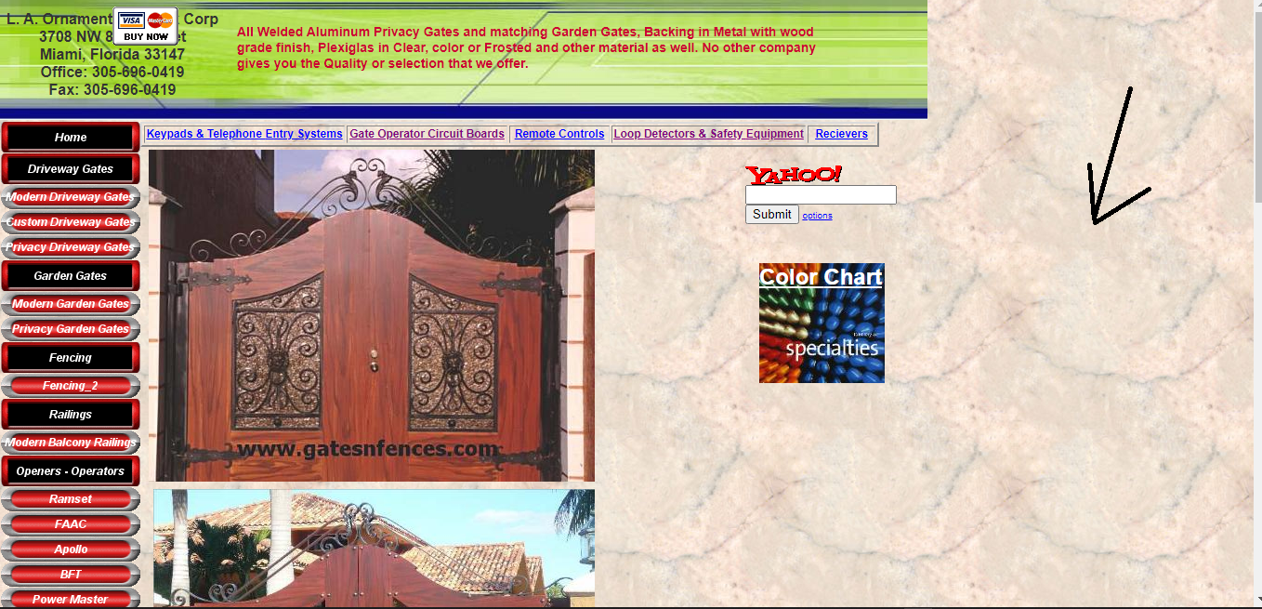

|  |  |
| --- | --- |
| ID number | #13 |
| Name | **Price chart is missing on the “Mirabella-Privacy-Entrance-Gate” page** |
| Reporter | Sanja Vasiljevic |
| Submit Date | 24/04/2022 |
| URL | <http://www.gatesnfences.com/index.html> |
| Platform | Windows 10 Pro Version 21H2 |
| Operating System | OS build 19044.1645 |
| Browser | Google Chrom Version 100.0.4896.127 |

**Steps to reproduce**

1. Open the http://www.gatesnfences.com/index.html page
2. Click on the **“**Privacy Gates**”** button on theleft side bar
3. The “Privacy Gates” page will be displayed
4. Click on the lower left image on top of the page ( <https://prnt.sc/quy1hk> )
5. The “Mirabella-Privacy-Entrance-Gate” page will be displayed
6. Scroll down
7. The price chart is missing

**Screencast**

[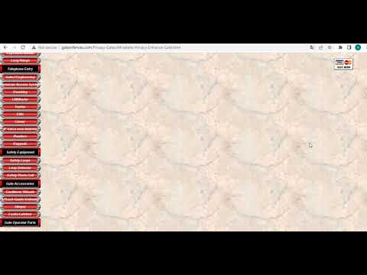](https://www.youtube.com/embed/cbfL6aE1vGw?feature=oembed)

|  |  |
| --- | --- |
| ID number | #14 |
| Name | **Description is missing on the “Modern Privacy Gate” page** |
| Reporter | Sanja Vasiljevic |
| Submit Date | 24/04/2022 |
| URL | <http://www.gatesnfences.com/index.html> |
| Platform | Windows 10 Pro Version 21H2 |
| Operating System | OS build 19044.1645 |
| Browser | Google Chrom Version 100.0.4896.127 |

**Steps to reproduce**

1. Open the http://www.gatesnfences.com/index.html page
2. Click on the **“**Privacy Gates**”** button on theleft side bar
3. The “Privacy Gates” page will be displayed
4. Scroll down
5. Click on the upper left image (first image)
6. The “Modern Privacy Gate” page will be displayed
7. Check the page
8. The description is missing

**Screenshot**

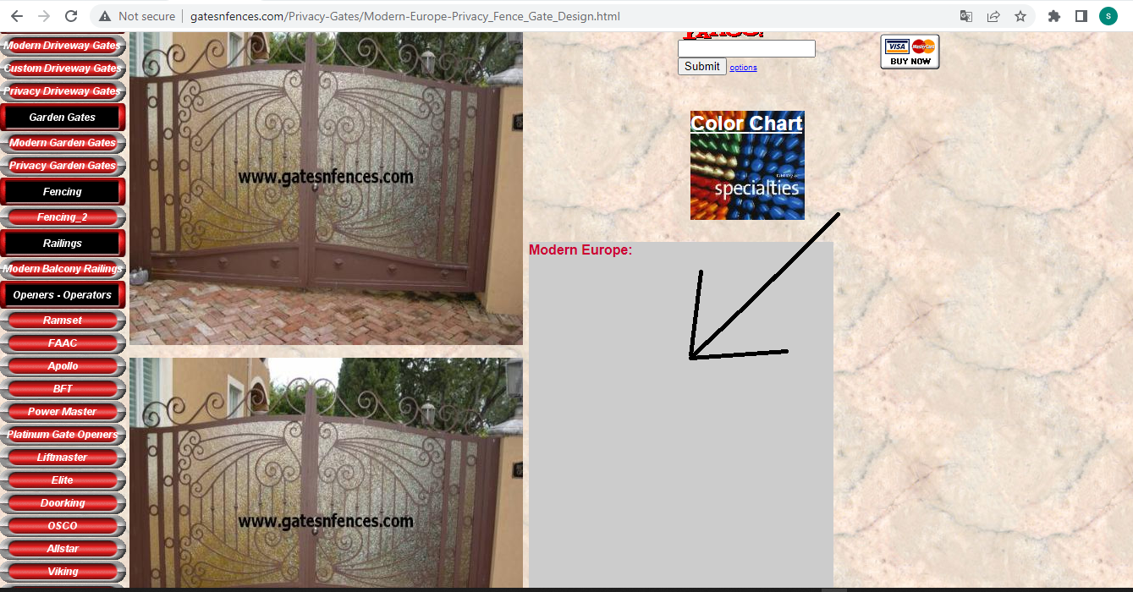

|  |  |
| --- | --- |
| ID number | #1 |
| Name | **Price chart is overlapping footer** |
| Reporter | Sanja Vasiljevic |
| Submit Date | 24/04/2022 |
| URL | http://www.gatesnfences.com/index.html |
| Platform | Windows 10 Pro Version 21H2 |
| Operating System | OS build 19044.1645 |
| Browser | Google Chrom Version 100.0.4896.127 |

**Steps to reproduce**

1. Open the <http://www.gatesnfences.com/index.html>

2. Click on “Modern Driveway Gates” button on left side bar.

3. The “Aluminum_Driveway_Gates_3” page displayed

4. Click on second image at first gallery line.

5. The “Musical_Notes-Front-Entrances-Gates-Driveway-Entrances-Gates” page displayed

6. Scroll down

7. Price chart is overlapping footer.

**Screenshot**

